
www.totolink.net

How to use QoS function to limit device network speed
Background Introduction:
It is suitable for: TOTOLINK All Models
The network bandwidth resources are limited, and some terminal devices such as high-speed downloads and video live streaming will occupy a large amount of bandwidth, leading to other computers experiencing phenomena such as "slow internet access, high network cards, and high game ping values with large fluctuations".
The QoS function can limit the maximum uplink and downlink rates of computers, thereby ensuring the rational utilization of the entire network bandwidth resources.
Set up steps
STEP 1: Log in to the router management page
In the browser address bar, enter: itoolink.net. Press the Enter key, and if there is a login password, enter the router management interface login password and click "Login".
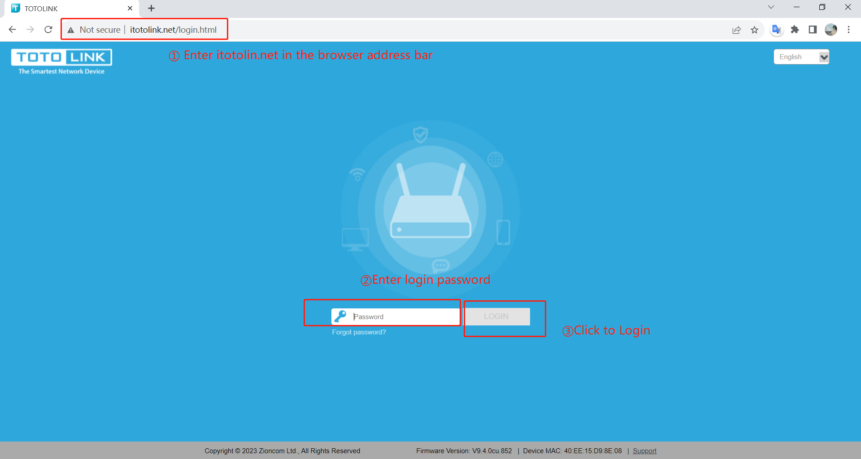

STEP 2: Enable QoS function
Find the basic settings as shown in the following figure, locate the QoS switch, and enable it
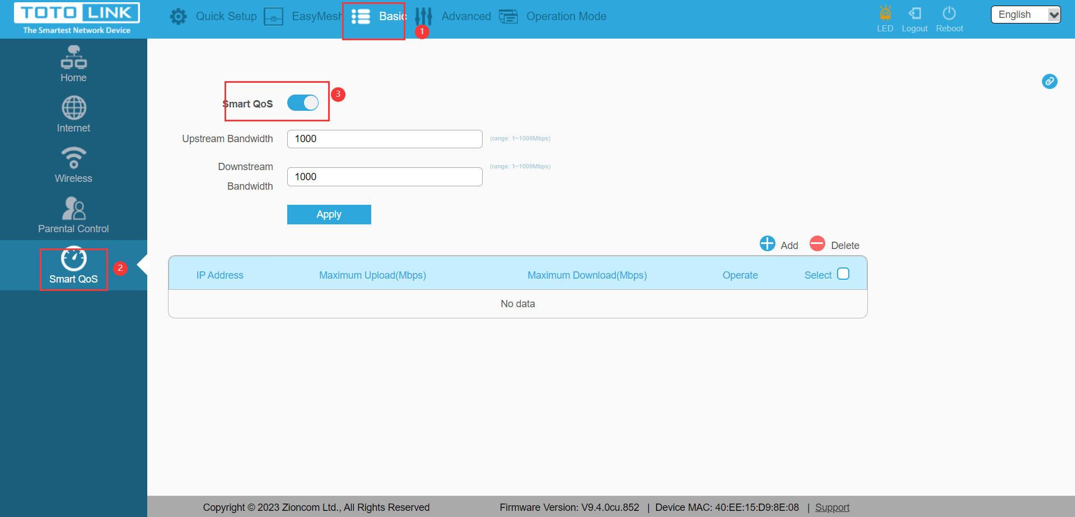
STEP 3：Set total bandwidth

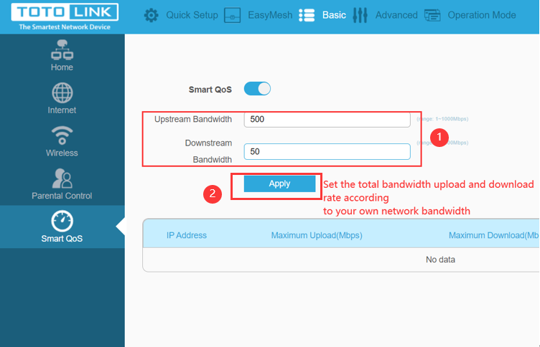
STEP 4：Add restricted devices
1. Select the 'Add' option from the rule list below.
2. Click on "Magnifier icon" to display the list of currently connected devices.
3. Select the device you want to limit bandwidth on. (The illustrated items are only examples)
4. Specify the upload and download bandwidth size you want to limit.
5. Click the "Add" button on the right side of the rule to add it.
